

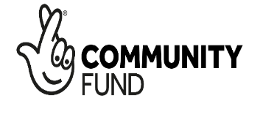
DERBYSHIRE UNEMPLOYED

WORKERS’ CENTRES

Administrator (Help is Here Project)

Salary: - £11,600

Contract: - Full time (16 hrs per week)

Job Share: - suitable for job share

Dates to note: -

- Deadline for applications: Friday July 3rd 2026
- Shortlisting: Wednesday 8th July 2026
- Interviews: Friday 24th July 2026 (Chesterfield)
Born out of the local Trade Union movement, DUWC is one of the most innovative campaigning advice centres in the country. We are looking for an Administrator to support our HELP IS HERE Migrant Advice Project based in Shirebrook, Derbyshire having responsibility for the administrative functions of the organisation.
The Administrator will be responsible for the smooth running and efficient operation of the service through reception duties, supporting volunteers, maintaining office supplies, diarising appointments, meetings and tribunals as well as administration duties supporting the Project steering group.
Candidates will be selected on the basis of meeting the immediate requirements of the post in terms of proven skills, knowledge and experience. The Centre is looking to reach out to under-represented groups in our organisation.
The salary will start at £11,600 for a 16 hour working week (over four days) with a 6% employer’s contribution to pension. Holiday entitlement will be 17.5 working days in a full leave year plus statutory holidays. Five extra days after completing five year’s continuous service. The post is funded for two years initially but the organisation is confident of attracting further funding into the future.
The post will be primarily located in Shirebrook
A full information pack is available through our website

For an informal chat please contact the Co-ordinator Colin Hampton on 07870 387999
Application method: email colin.hampton@duwc.org.uk

